MVC Architecture in Java
What is MVC architecture in Java?
The Model-View-Controller (MVC) architecture in Java is a design pattern that provides a structured approach for developing applications. It separates the application’s concerns into three main components: the model, the view, and the controller. Each component has a specific role and responsibility within the architecture.
- Model:
The model represents the data and business logic of the application. It encapsulates the application’s data and provides methods for accessing, manipulating, and updating that data. The model component is independent of the user interface and focuses solely on the application’s functionality.
- View:
The view is responsible for rendering the user interface and displaying the data to the user. It presents the data from the model to the user in a visually appealing and understandable way. The view component does not contain any business logic but instead relies on the model for data.
- Controller:
The controller acts as an intermediary between the model and the view. It handles user input, processes user actions, and updates the model or view accordingly. The controller interprets user actions and triggers the appropriate methods in the model or view. It ensures the separation of concerns by keeping the view and model independent of each other.
In Java programming, the Model comprises basic Java classes that encapsulate data and business logic. The View is responsible for presenting the data to the user interface, while the Controller consists of servlets that handle user requests. This clear separation of components enables the following processing flow for user requests:
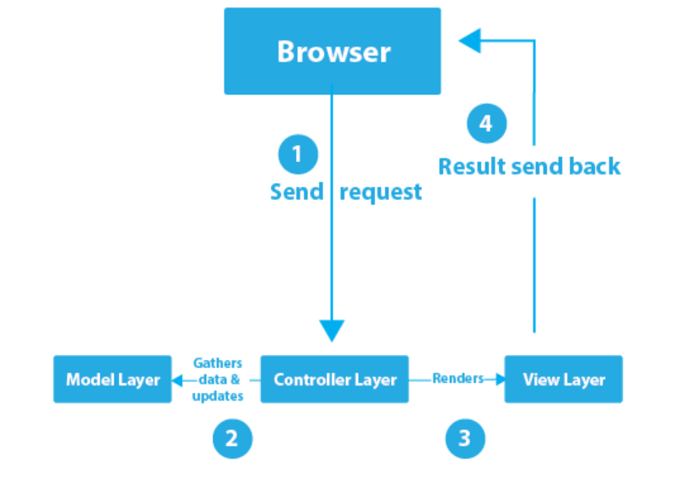
In the context of the server-client architecture, the process of handling a page request can be described as follows:
- A client, typically a web browser, initiates a request and sends it to the server-side controller.
- The controller receives the request and interacts with the model component. It retrieves the necessary data from the model, which may involve processing and manipulating the data as required.
- Once the controller has gathered the requested data, it transfers this data to the view layer.
- The view layer, utilizing the provided data, generates the appropriate output or representation of the requested page. Finally, the generated result is sent back to the client’s browser, completing the request-response cycle.
Advantages of MVC Architecture in Java
The MVC (Model-View-Controller) architecture offers several advantages in Java development:
- Separation of Concerns: MVC promotes a clear separation of concerns between the model, view, and controller components. This separation allows for better code organization, improved modularity, and easier maintenance. Developers can focus on specific aspects of the application without impacting other components.
- Code Reusability: By separating the concerns into distinct components, code reuse becomes more feasible. The model can be reused across different views, and multiple views can be created for a single model. This reusability reduces duplication of code and improves development efficiency.
- Simultaneous Development: MVC allows multiple developers to work simultaneously on different components. The model, view, and controller can be developed independently as long as they adhere to the defined interfaces and communication protocols. This parallel development approach accelerates the overall development process.
- Flexibility and Extensibility: MVC provides flexibility by allowing changes in one component without affecting others. For example, modifying the view does not require altering the model or controller. This flexibility also enables the easy addition of new views or controllers to enhance the application’s functionality.
- Testability: The separation of concerns in MVC makes unit testing and debugging more manageable. Each component can be independently tested, as they have well-defined responsibilities and interfaces. This promotes comprehensive testing, reduces dependencies, and improves the overall quality of the application.
- Enhanced User Experience: With MVC, the view layer handles the presentation of data to the user. This separation allows for greater control over the user interface and enables the use of different views for different platforms or devices. Developers can create responsive and user-friendly interfaces tailored to specific user needs.
- Support for Maintainability: MVC simplifies the maintenance of applications over time. Changes can be made to individual components without requiring extensive modifications to the entire system. This modularity enhances maintainability and reduces the risk of introducing bugs or breaking existing functionality.
Implementation of MVC using Java
To implement a web application based on MVC design pattern, we will create
- Course Class, which acts as the model layer
- CourseView Class, which defines the presentation layer (view layer)
- CourseContoller Class, which acts as a controller
Now, let’s explore these layers one by one.
The Model Layer
In the MVC design pattern, the model is the data layer which defines the business logic of the system and also represents the state of the application. The model objects retrieve and store the state of the model in a database. Through this layer, we apply rules to data, which eventually represents the concepts our application manages. Now, let’s create a model using Course Class.
package MyPackage;
public class Course {
private String CourseName;
private String CourseId;
private String CourseCategory;
public String getId() {
return CourseId;
}
public void setId(String id) {
this.CourseId = id;
}
public String getName() {
return CourseName;
}
public void setName(String name) {
this.CourseName = name;
}
public String getCategory() {
return CourseCategory;
}
public void setCategory(String category) {
this.CourseCategory = category;
}
}

The View Layer

This layer of the MVC design pattern represents the output of the application or the user interface. It displays the data fetched from the model layer by the controller and presents the data to the user whenever asked for. It receives all the information it needs from the controller and it doesn’t need to interact with the business layer directly. Let’s create a view using CourseView Class.
package MyPackage;

public class CourseView {
public void printCourseDetails(String CourseName, String CourseId, String CourseCategory){
System.out.println("Course Details: ");
System.out.println("Name: " + CourseName);
System.out.println("Course ID: " + CourseId);
System.out.println("Course Category: " + CourseCategory);
}
}
This code is simply to print the values to the console. Next up we have the controller of the web application.
The Controller Layer
The Controller is like an interface between Model and View. It receives the user requests from the view layer and processes them, including the necessary validations. The requests are then sent to model for data processing. Once they are processed, the data is again sent back to the controller and then displayed on the view. Let’s create CourseContoller Class which acts as a controller.
package MyPackage;

public class CourseController {
private Course model;
private CourseView view;

public CourseController(Course model, CourseView view){
this.model = model;
this.view = view;
}

public void setCourseName(String name){
model.setName(name);
}

public String getCourseName(){
return model.getName();
}

public void setCourseId(String id){
model.setId(id);
}

public String getCourseId(){
return model.getId();
}

public void setCourseCategory(String category){
model.setCategory(category);
}

public String getCourseCategory(){
return model.getCategory();
}
public void updateView(){
view.printCourseDetails(model.getName(), model.getId(), model.getCategory());
}
}
this controller class is just responsible for calling the model to get/set the data and updating the view based on that.
Main Java Class
Let’s call this class “MVCPatternDemo.java”. Check out the code below.
package MyPackage;
public class MVCPatternDemo {
public static void main(String[] args) {
//fetch records from the database
Course model = retrieveCourseFromDatabase();
//Create a view : to write course details on console
CourseView view = new CourseView();
CourseController controller = new CourseController(model, view);
controller.updateView();
//update model data
controller.setCourseName("Python");
System.out.println("nAfter updating, Course Details are as follows");
controller.updateView();
}
private static Course retrieveCourseFromDatabase(){
Course course = new Course();
course.setName("Java");
course.setId("01");
course.setCategory("Programming");
return course;
}
}
The above class fetches the course data from the function using which user enters the set of values. It then pushes those values into the Course model. Then, it initializes the view we had created earlier in the article. Further, it also invokes the CourseController class and binds it to the Course class and the CourseView class. The updateView() method which is a part of the controller then updates the course details on the console. Check out the output below.
Output
Course Details:
Name: Java
Course ID: 01
Course Category: Programming

After updating, Course Details are as follows
Course Details:
Name: Python
Course ID: 01
Course Category: Programming

Example2:
/ class that represents model
package MyPackage;
// Model Class (Employee)
public class Employee {
private String employeeName;
private String employeeId;
private String employeeDepartment;
// Getter and Setter Methods
public String getId() {
return employeeId;
}
public void setId(String id) {
this.employeeId = id;
}
public String getName() {
return employeeName;
}
public void setName(String name) {
this.employeeName = name;
}
public String getDepartment() {
return employeeDepartment;
}
public void setDepartment(String department) {
this.employeeDepartment = department;
}
}

// View Class (EmployeeView)
public class EmployeeView {
// Method to display Employee details
public void printEmployeeDetails(String employeeName, String employeeId, String employeeDepartment){
System.out.println("Employee Details: ");
System.out.println("Name: " + employeeName);
System.out.println("Employee ID: " + employeeId);
System.out.println("Employee Department: " + employeeDepartment);
}
}

// Controller Class (EmployeeController)
public class EmployeeController {
private Employee model;
private EmployeeView view;
// Constructor to initialize model and view
public EmployeeController(Employee model, EmployeeView view) {
this.model = model;
this.view = view;
}
// Method to initialize Employee details
public void initializeEmployee(String name, String id, String department) {
model.setName(name);
model.setId(id);
model.setDepartment(department);
}
// Getter and Setter Methods
public void setEmployeeName(String name){
model.setName(name);
}
public String getEmployeeName(){
return model.getName();
}
public void setEmployeeId(String id){
model.setId(id);
}
public String getEmployeeId(){
return model.getId();
}
public void setEmployeeDepartment(String department){
model.setDepartment(department);
}
public String getEmployeeDepartment(){
return model.getDepartment();
}

// Method to update view
public void updateView() {
view.printEmployeeDetails(model.getName(), model.getId(), model.getDepartment());
}
}

// Main Class (Entry Point)
public class Main {
public static void main(String[] args) {
// Create Model and View
Employee model = new Employee();
EmployeeView view = new EmployeeView();
// Create Controller
EmployeeController controller = new EmployeeController(model, view);
// Initialize Employee details via Controller
controller.initializeEmployee("Jane Smith", "000", "HR");
// Display initial details
controller.updateView();
// Update Employee details through Controller
controller.setEmployeeName("John Doe");
controller.setEmployeeId("001");
controller.setEmployeeDepartment("IT");
System.out.println("\nAfter updating, Employee Details are as follows:");
controller.updateView();
}
}
Employee Details:
Name: Jane Smith
Employee ID: 000
Employee Department: HR

Employee Details:
Name: John Doe
Employee ID: 001
Employee Department: IT

